DATA MIGRATION FROM SOLID EDGE TO TEAMCENTER

A]. Migration of SOLID EDGE PARTS and DRAWING INTO TEAMCENTER.

1.Create a part and its drawing file into team center.

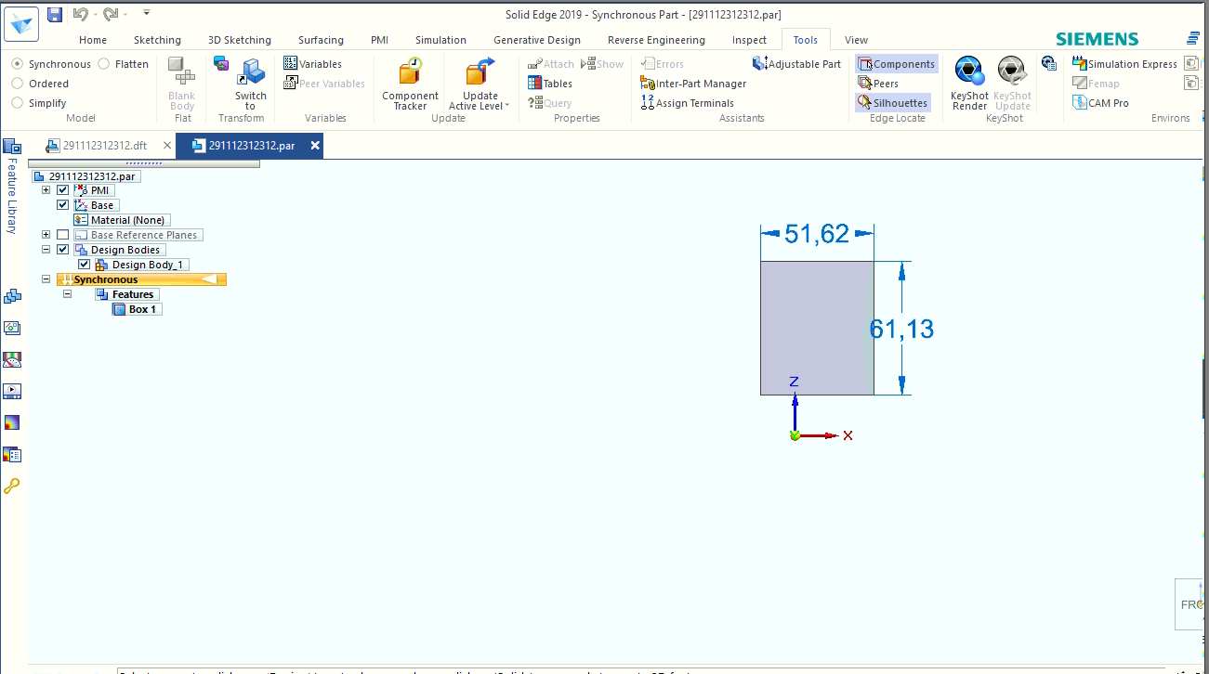

2. Select DATA Preparation Utility.

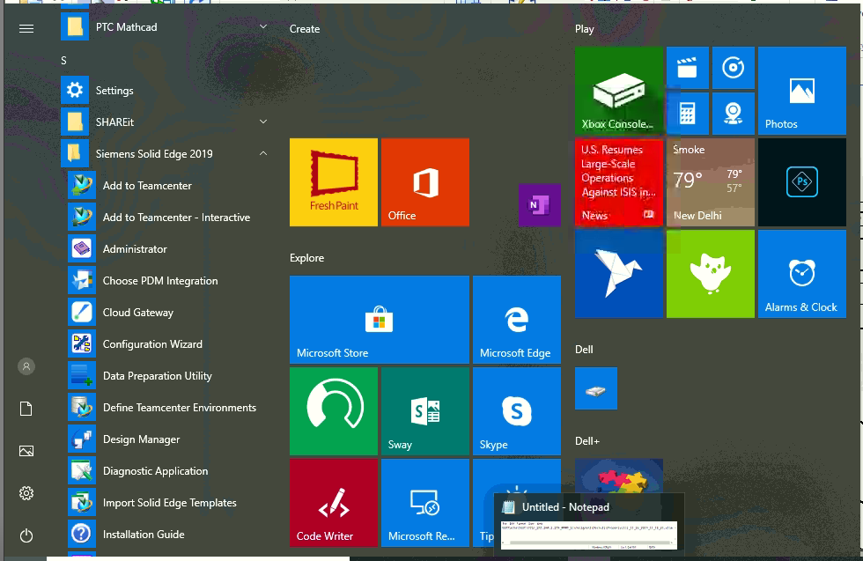

3.Set working directory from where data is required to be migrated.

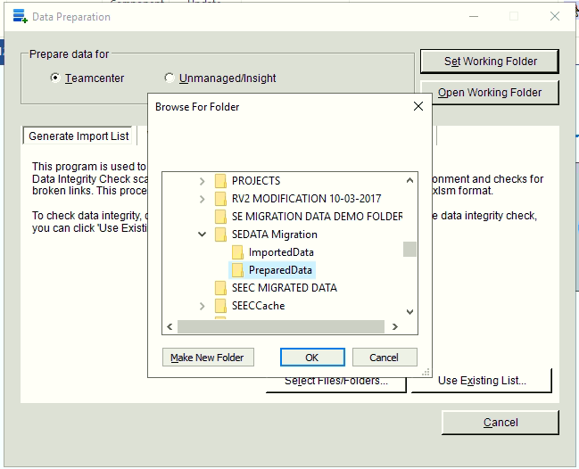

4.Select files /folders to migrate

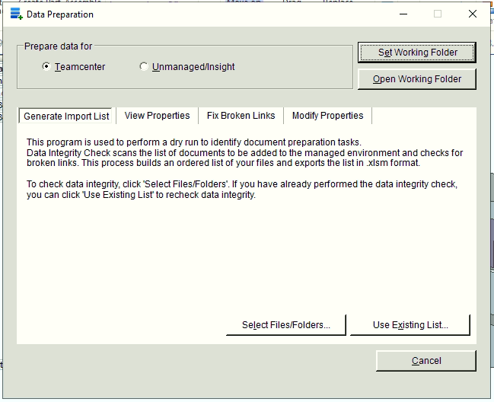

5.Add files /folders to migrate into team center

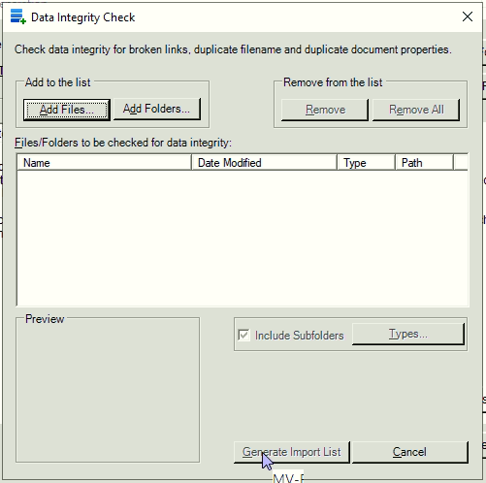

6. Add files /folders manually

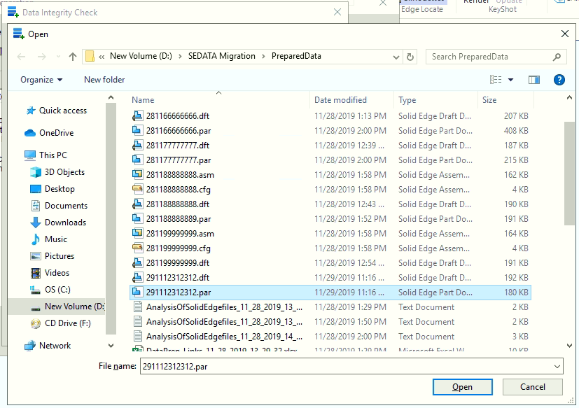

7. Select the parts ( .par) file

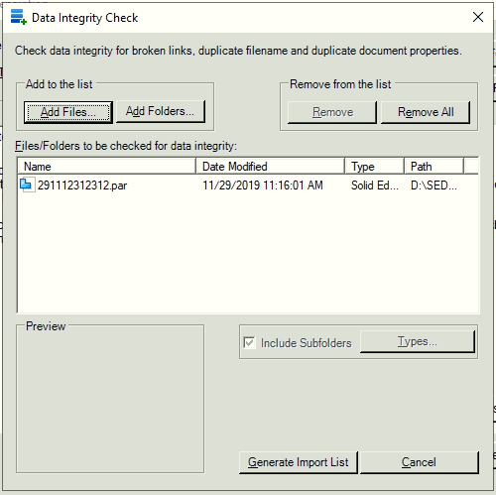

8.Click on generate import list



9.Message can be seen on screen while generating

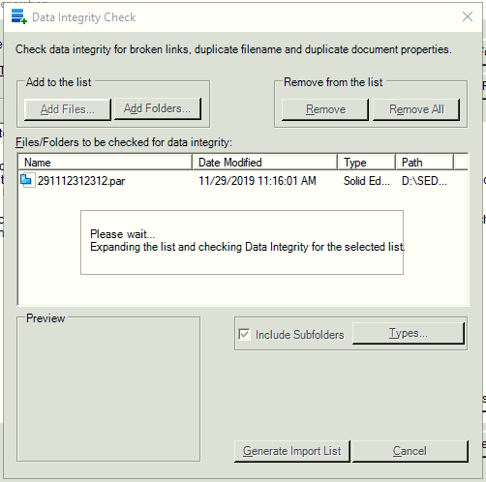

10.Excel file be generated at the working directory

Fill information in **New Path , Document Number, Revision, Teamcenter Item Type** columns**.**

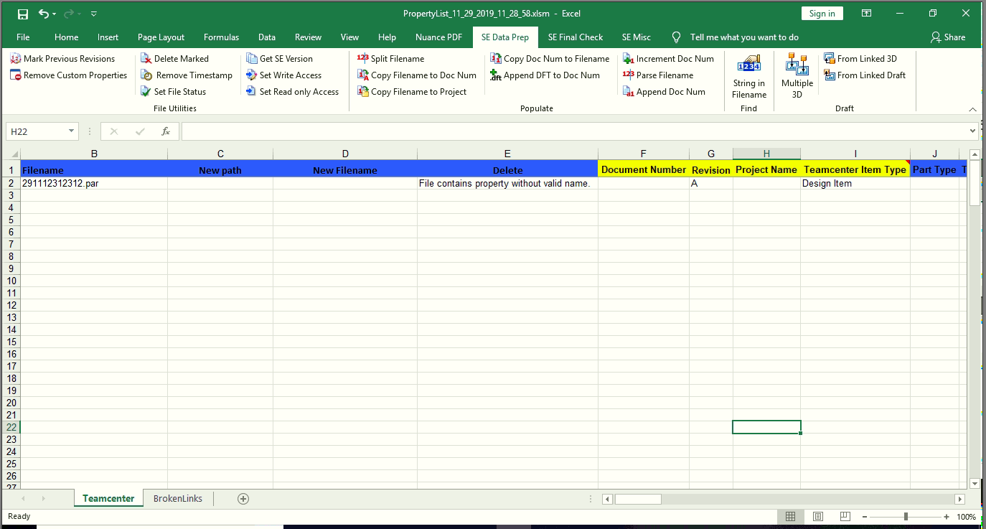

11.Select **SE Data Prep** tab click on **Copy Filename to Doc Num , Copy Filename to Project**  and **Copy Doc Num to Filename.**

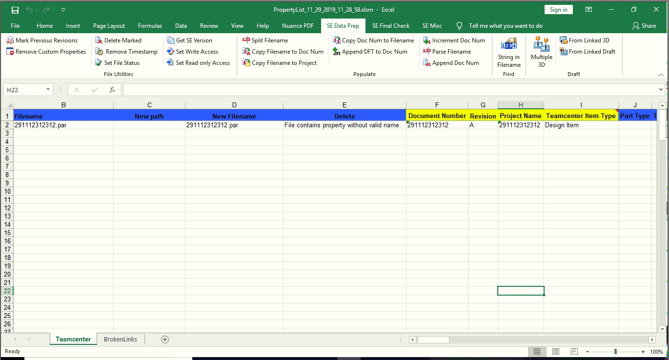

12.Give path of migrated data folder

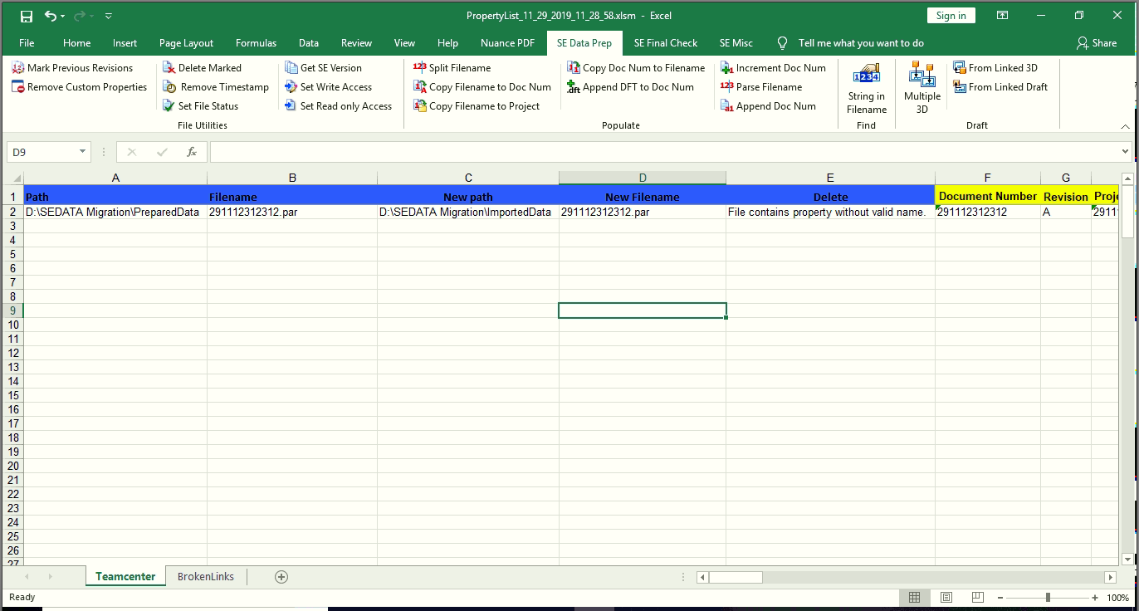

13.Save Excel file.

Click **Modify Properties** in **Data Preparation** window.

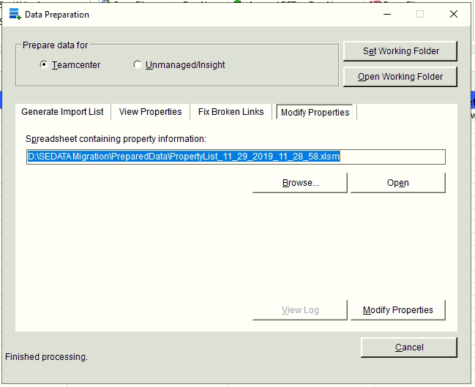

14.You can click on view log to check if process is completed successfully

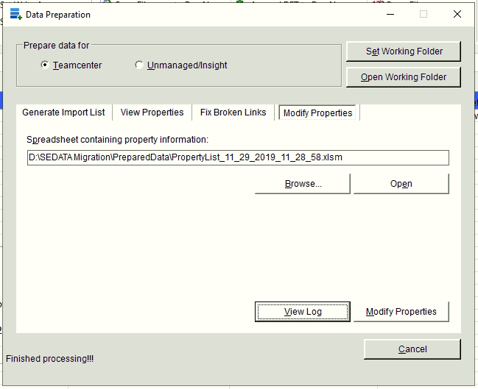

15.Open solid edge 🡪 manage 🡪 Add Document to teamcenter

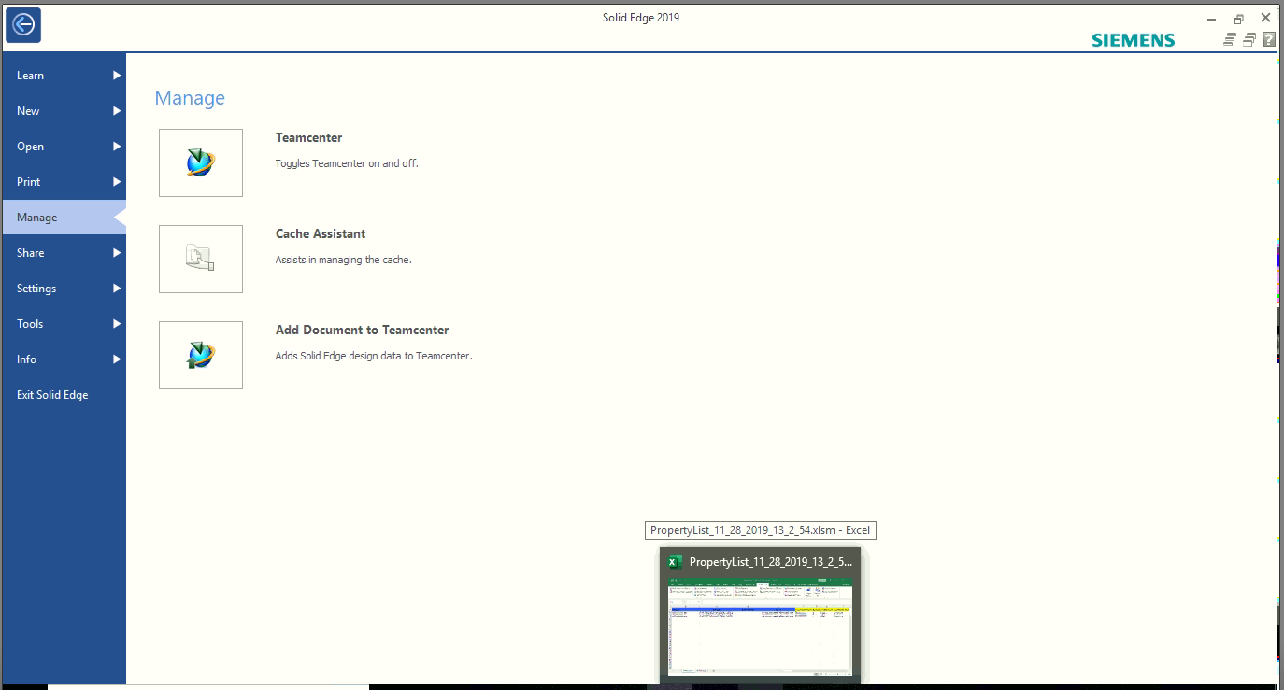

16.Give path of migration folder i.e folder which will contain migrated parts.

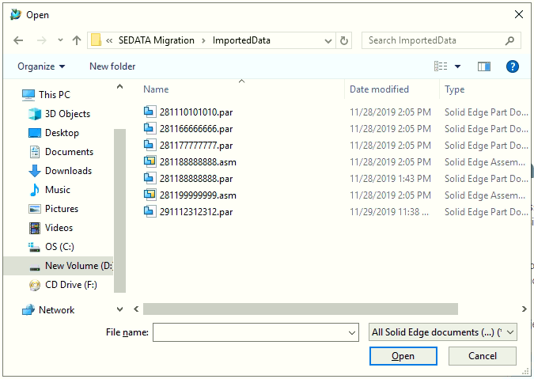

17.Login window will be displayed sign in into teamcenter

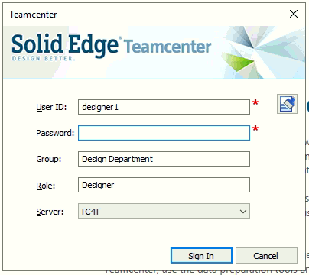

18.A new window will be displayed.Click on retrieve data from teamcenter icon.

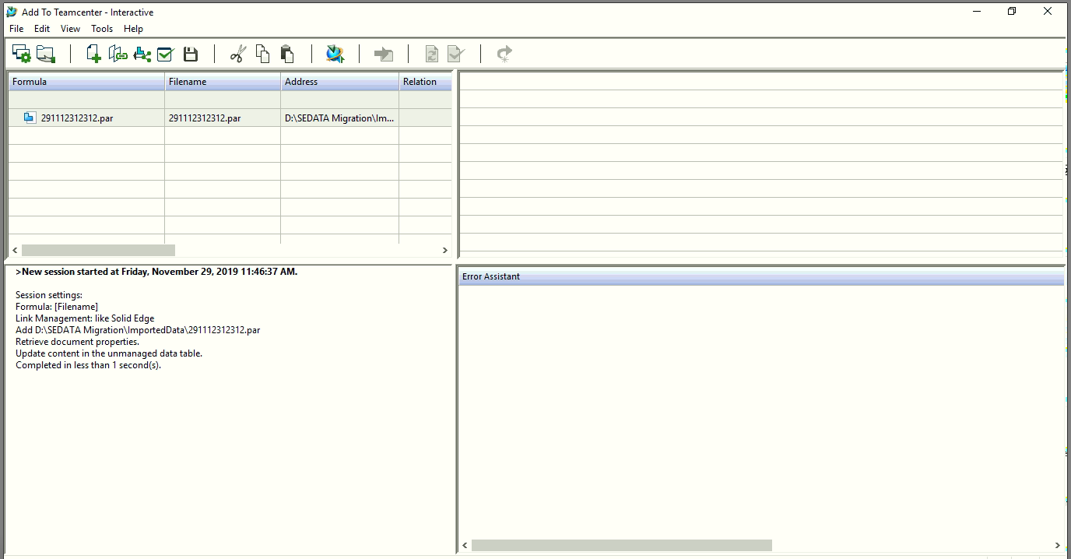

19.Click on Run teamcenter validation and after validations click on perform actions.

NOTE: In Teamcenter action tab you can check if your selected part is new or existing in teamcenter

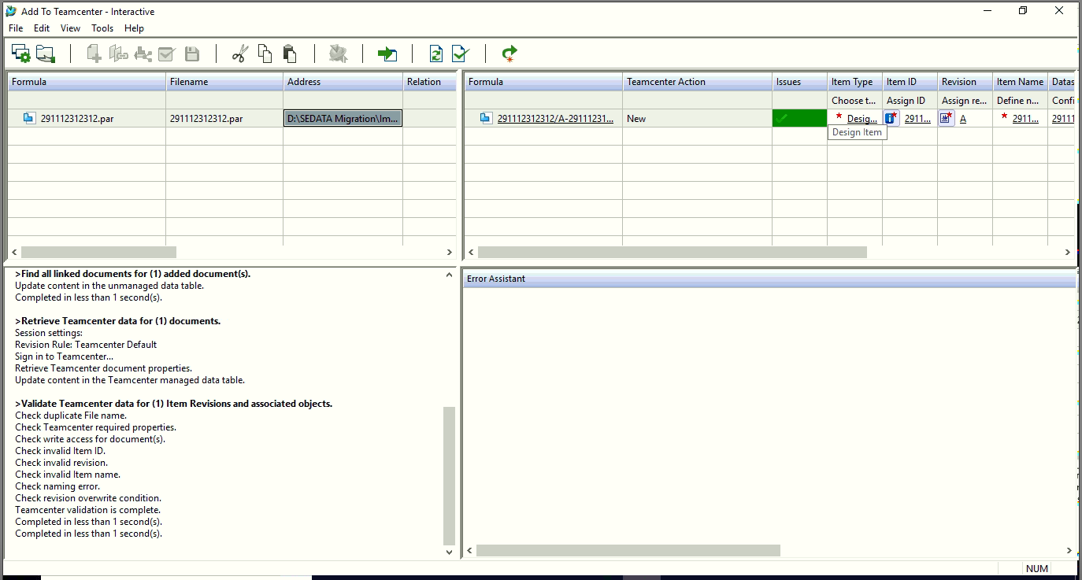

20.After completion click ok.

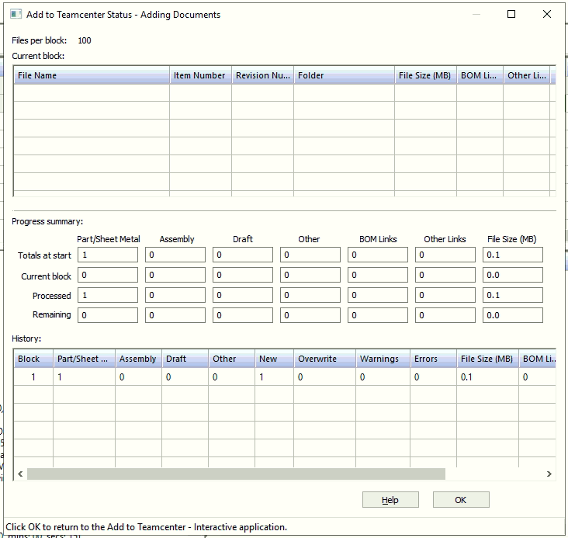

The data will get added to **Newstuff** folder.

Note : While part migration if the .dft file is not select during part selection in step 5 then .dft needs to be migrated separately

B].Migrating .dft file into teamcenetr from solid edge.

Follow the above steps till step no 17. Some random snaps are given below for your reference

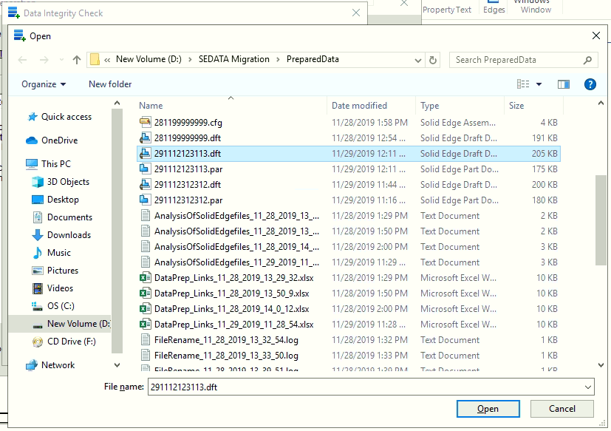

Note : while migration of your .dft files your part(.par)file will automatically get added to the excel sheet check the below image for reference.

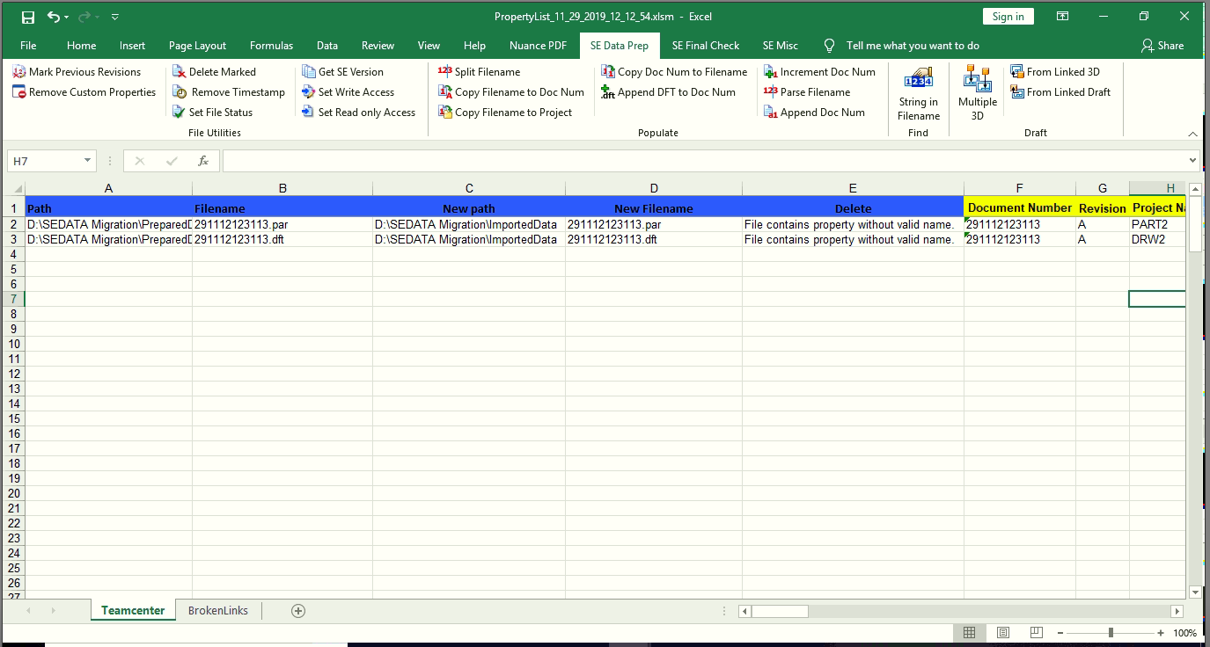

select the .dft file which you want to migrate

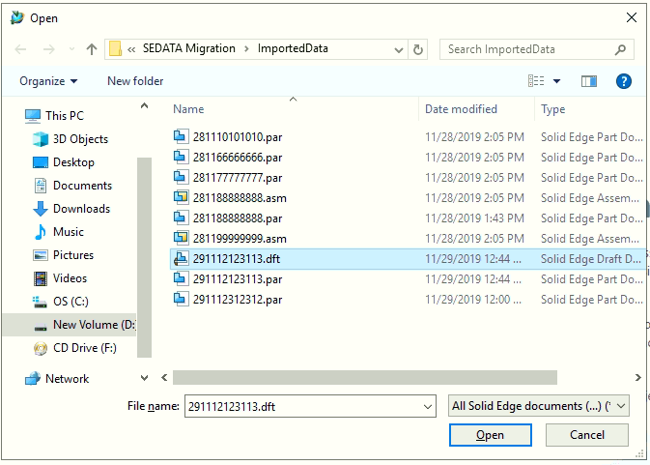

After logging in click on find all linked documents.

Note : you will find that the parts associated with the drawing will also be added to the window.

Click on retrieve data from teamcenter.

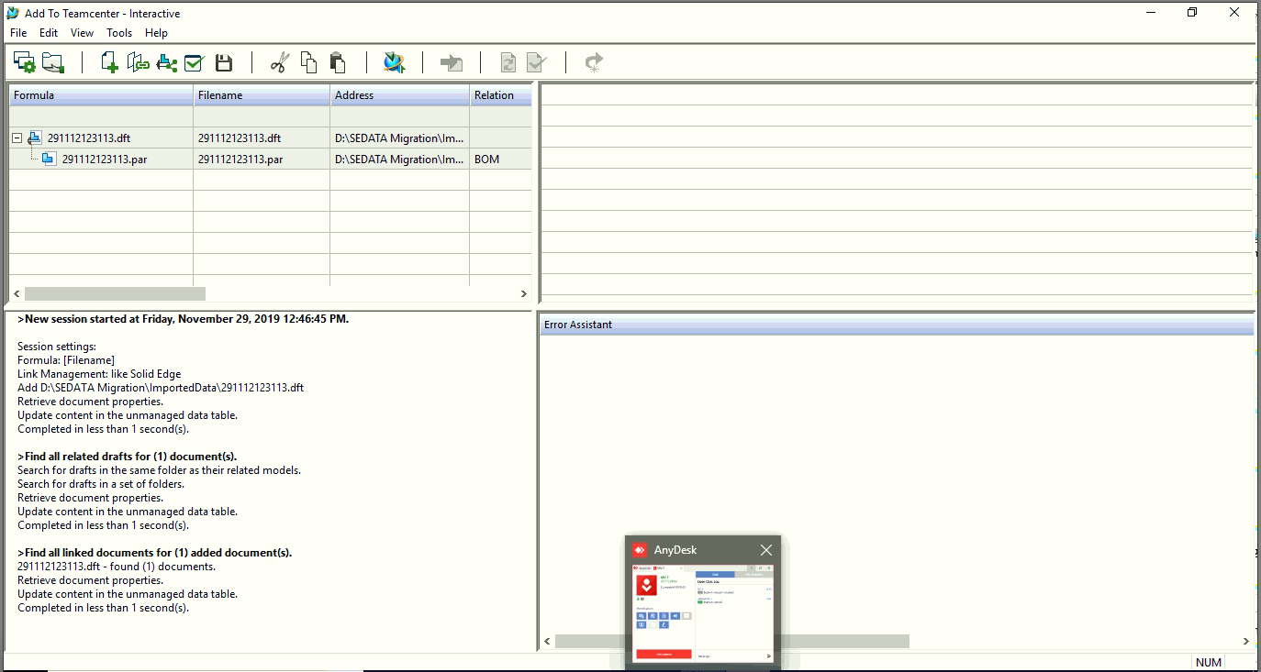

Click on retrieve data from teamcenter and perform the validations

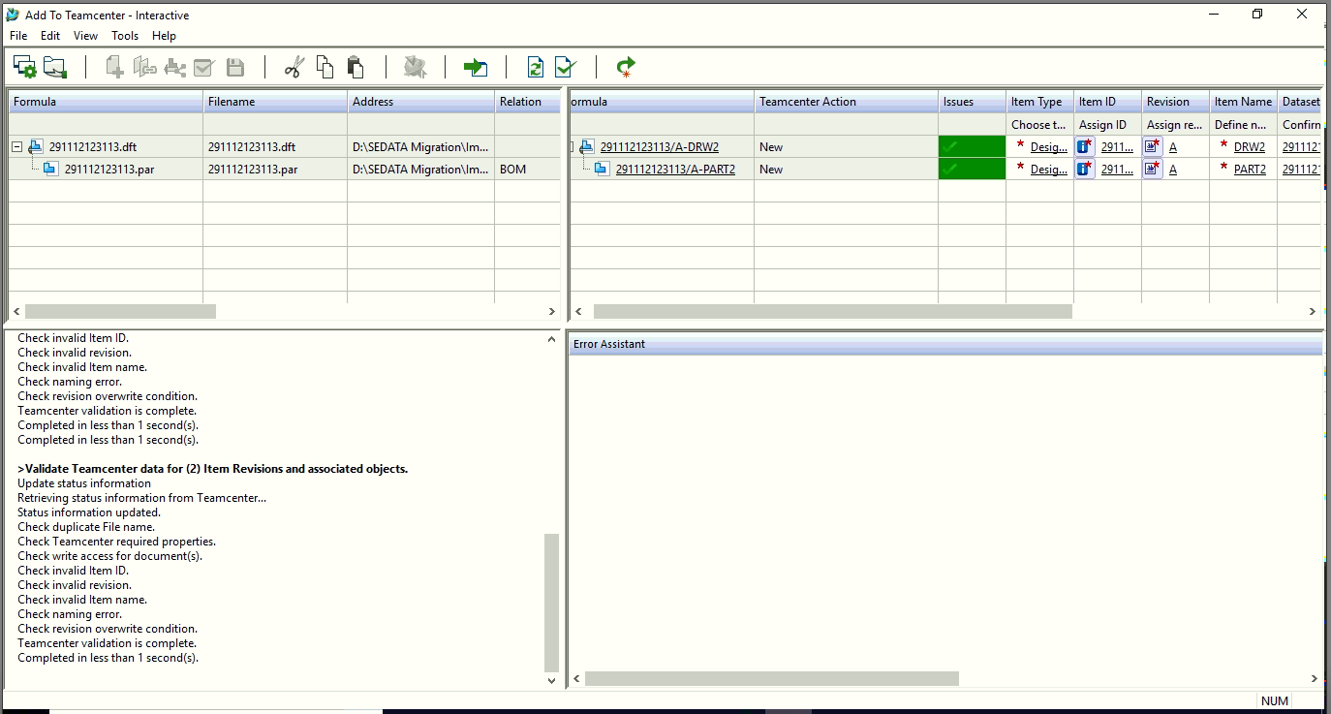

Status window will be displayed .

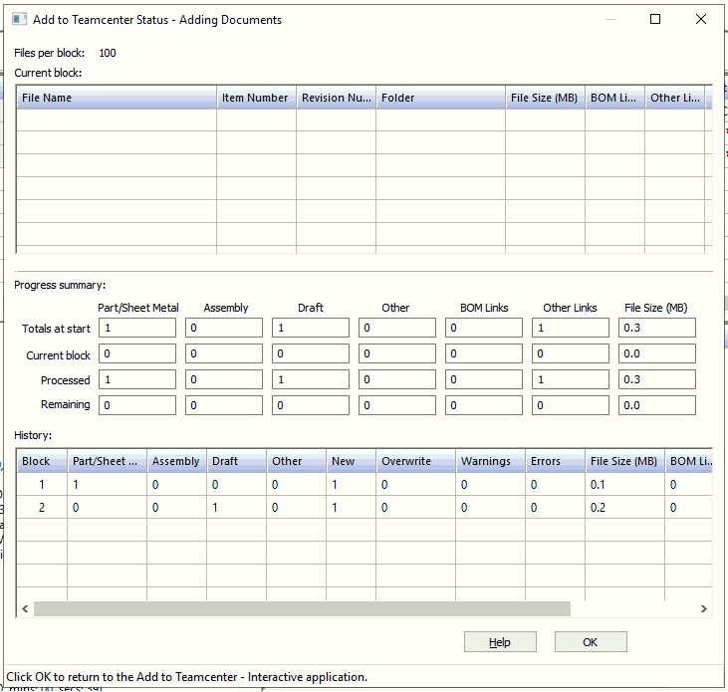

On completion click ok. Find the results in team center.

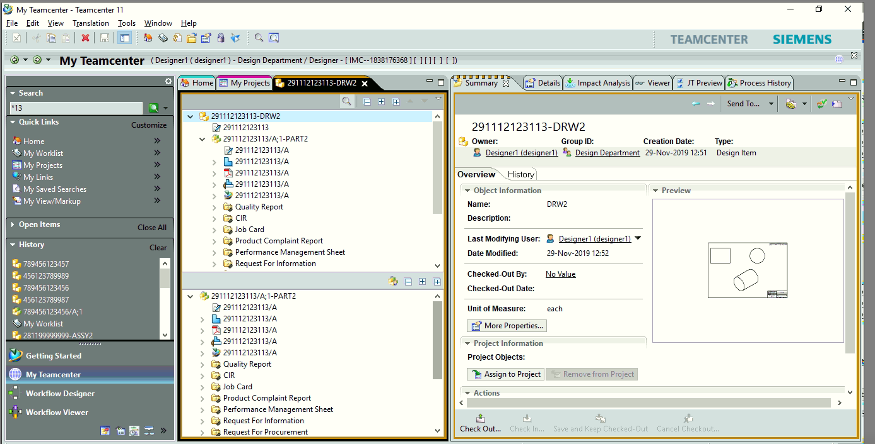

Note: The part associated with the drawing will also be migrated if its not been migrated before into team center.

C.] Migration of assembly into team center.

Follow the procedure till step no 17.

Below are few images for reference.

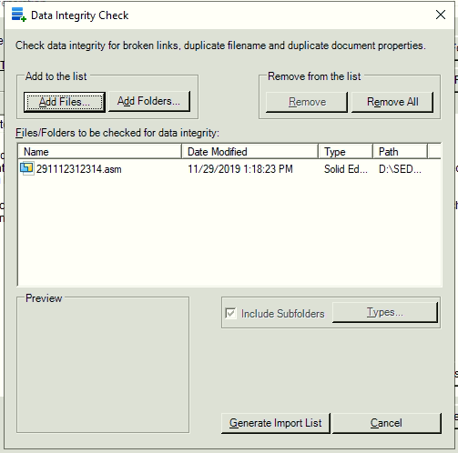

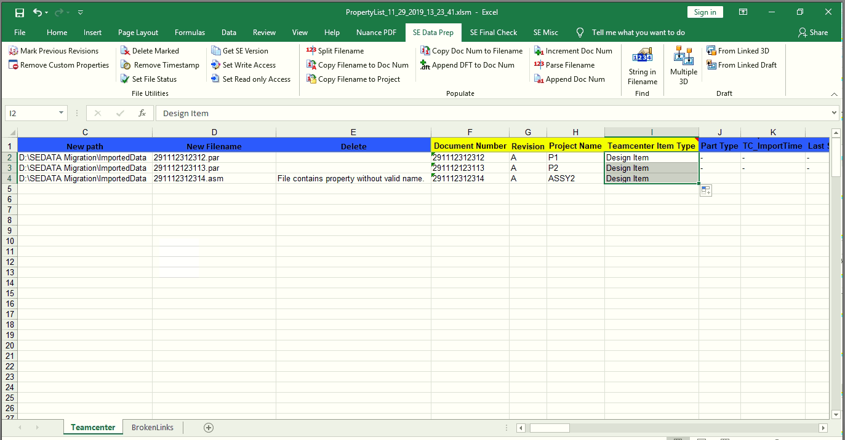

Broken link tab in excel file will display if any errors or broken linkages are there.

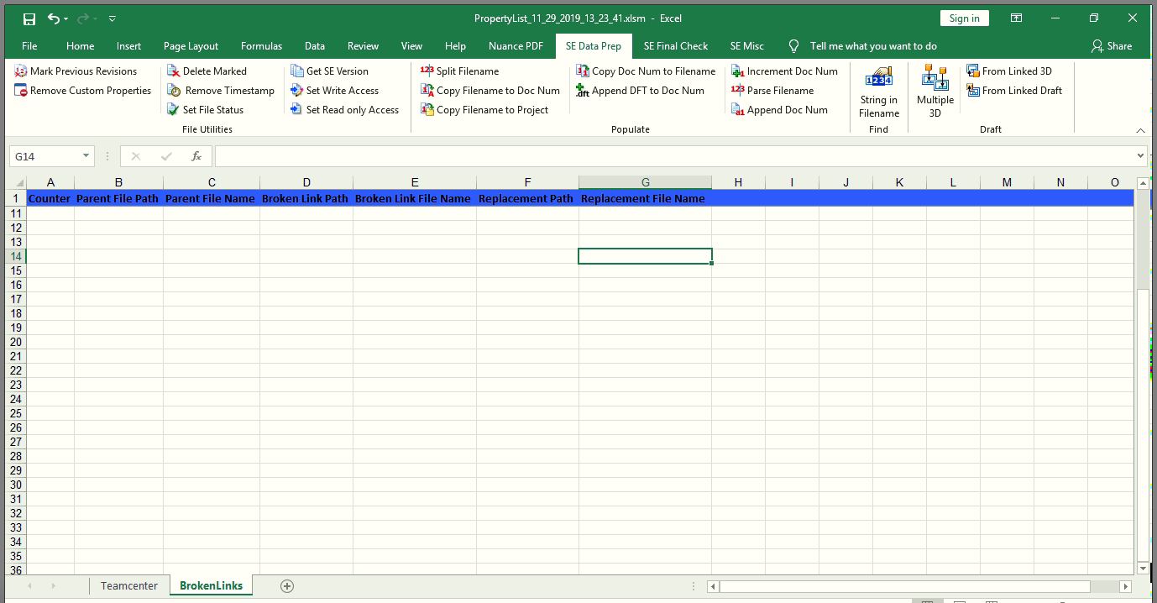

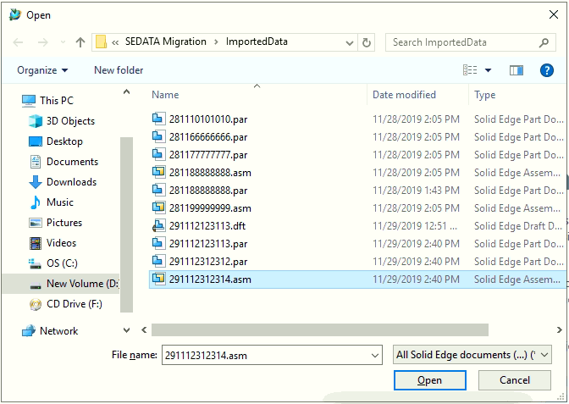

Continue the procedure till step 17.

After completing above steps till step 17 you can see the below window which contains the assembly

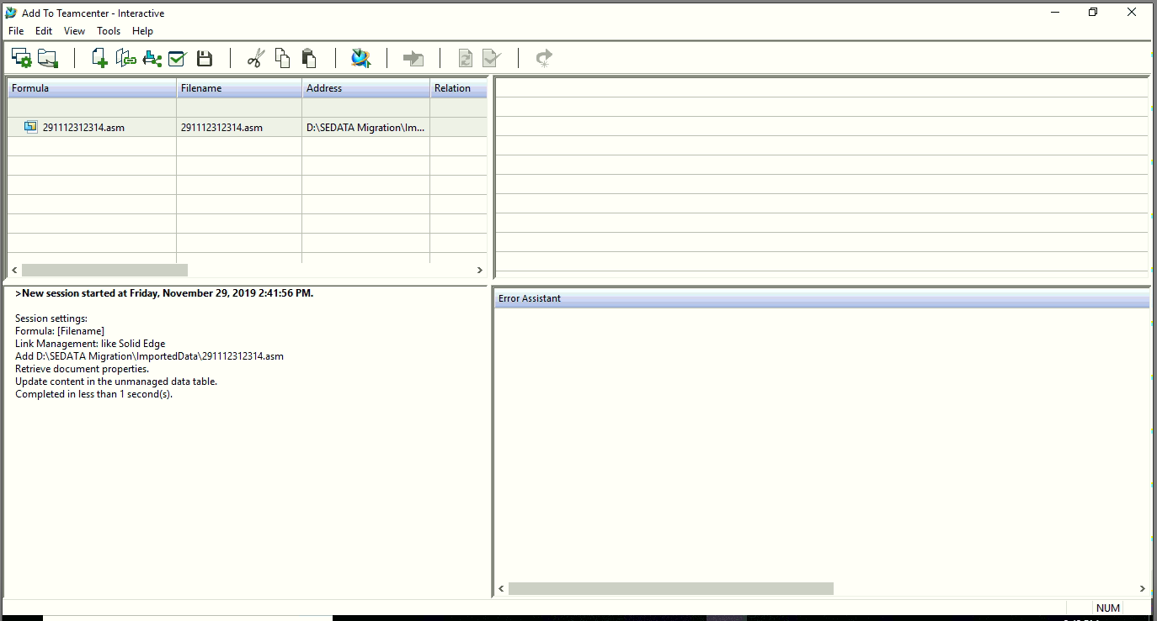

Click on find all linked documents. By clicking on it you will get all the parts attached which are associated with the assembly.

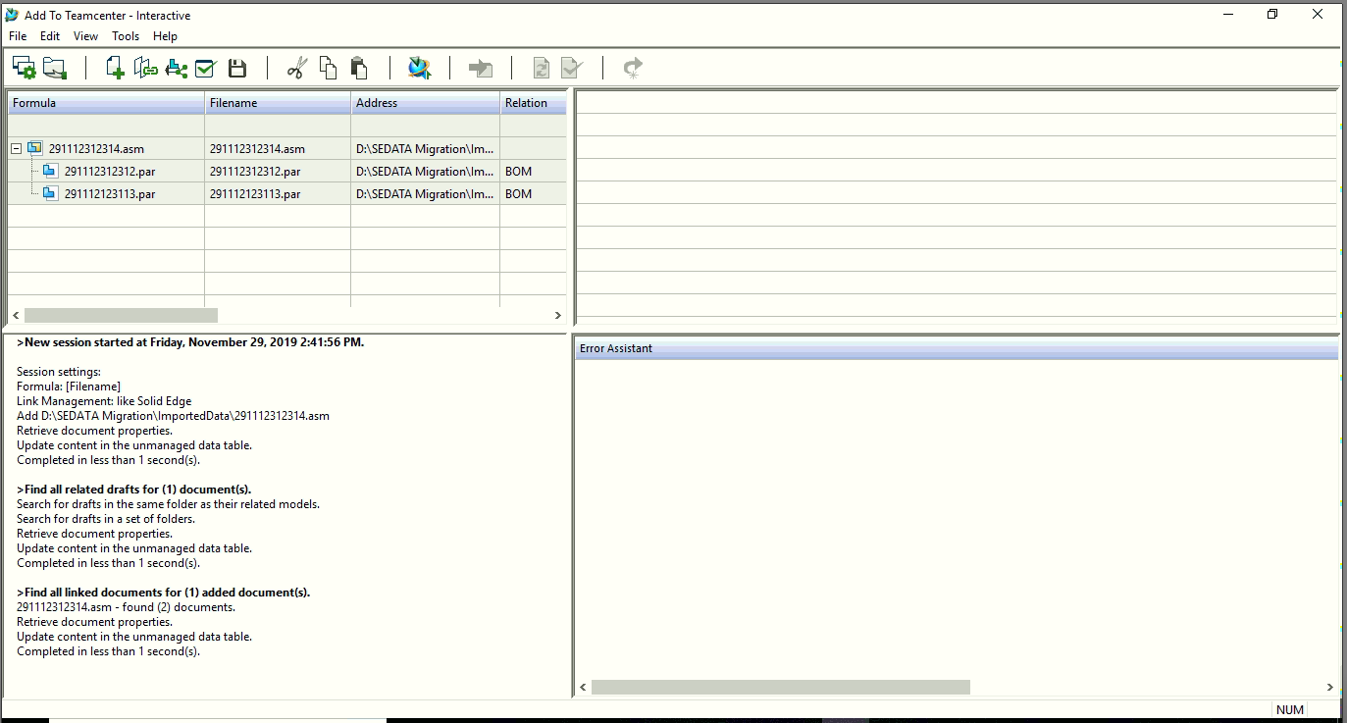

Click on retrieve data from team center and expand the Team center action tab .

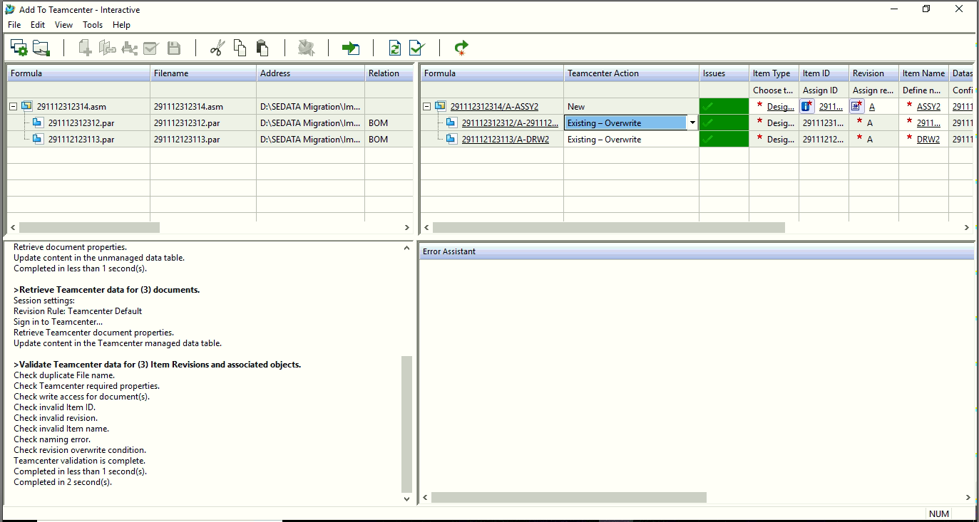

Select option Existing-Use existing as the parts are already present in team center

Note : You can see in above image that there are some pre-existing parts in team center so for that parts we need to select the option Existing – Use Existing.

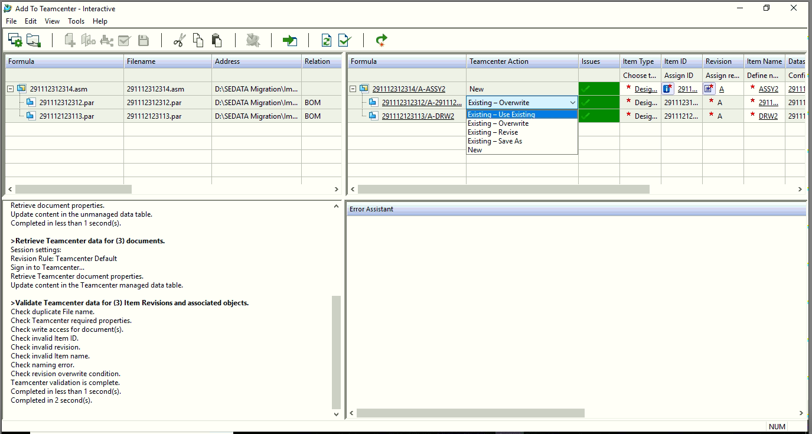

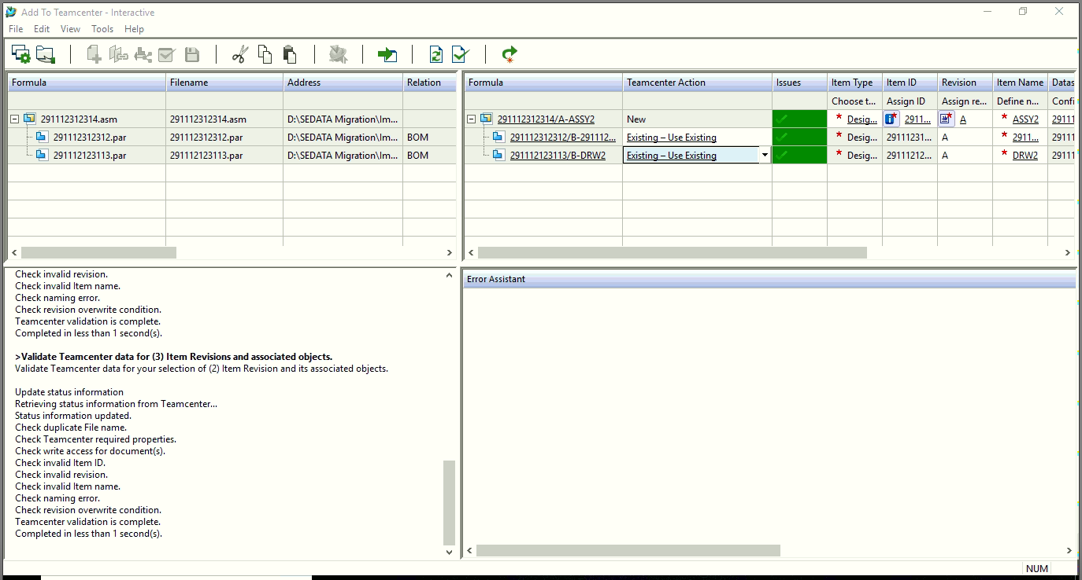

Click on perform action option.

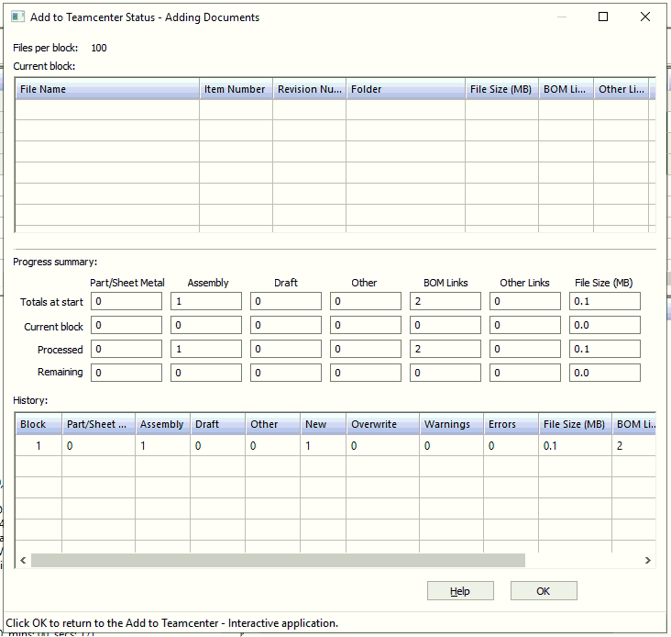

Check the result in team center.

You can find your assembly in team center.

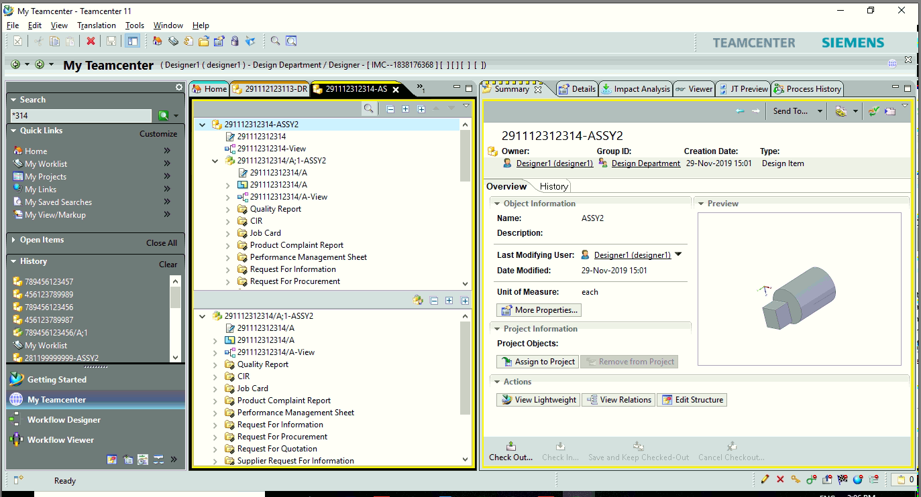

D.] For Assembly drawing follow the same above procedure

Follow the same procedure stated above for data migration.

Some images are given below for reference purpose

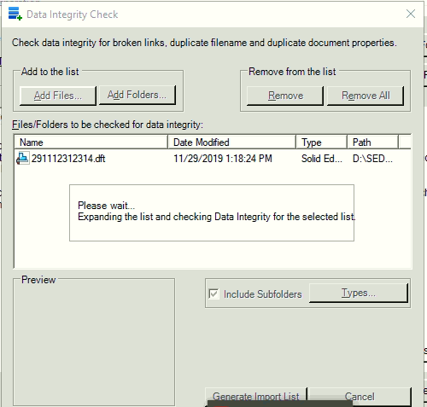

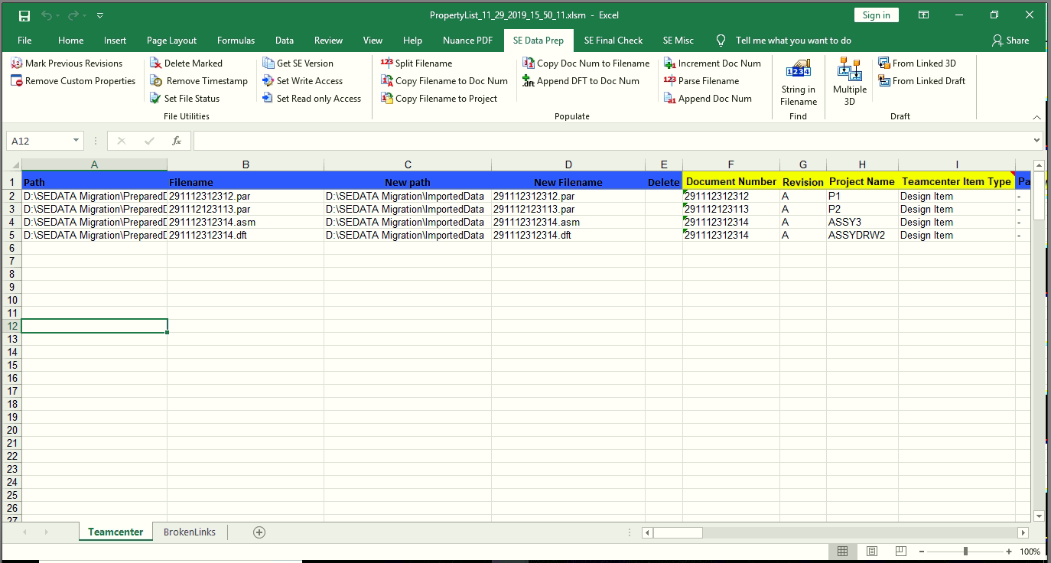

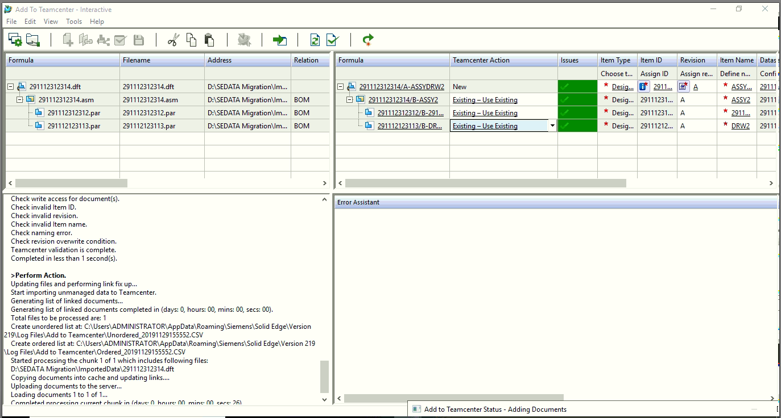

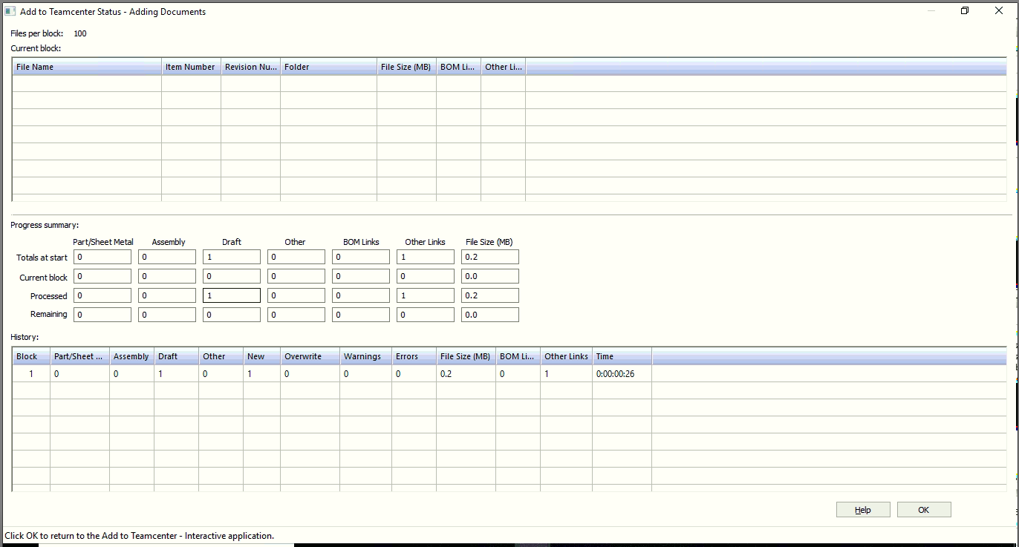

Validate the results in team center.

